**7.4 Right Triangle Stations**

Station #1: Pythagorean Theorem

*Solve for the missing side length in simplest radical form.*





Station #2: Isosceles Right Triangles

*Solve for the variable in simplest radical form.*

1. 2.

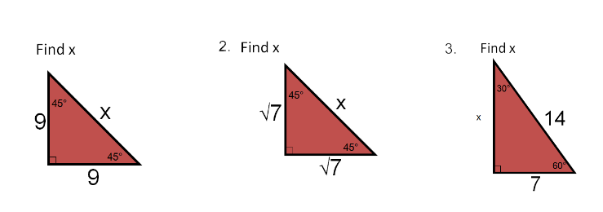 

3. 4. 5.

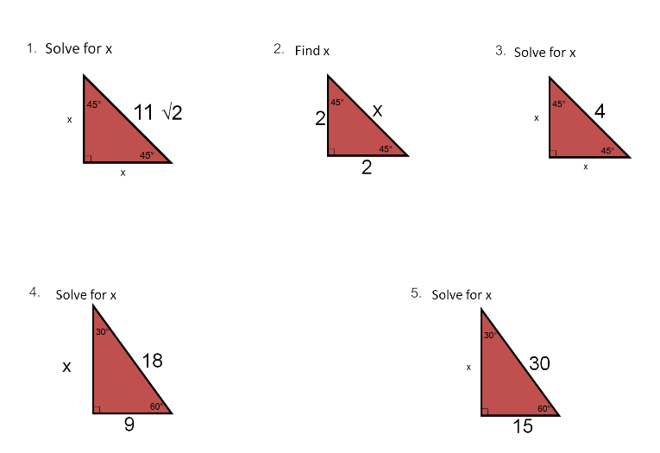

Station #3: 30-60-90 Right Triangles

*Solve for the variable in simplest radical form.*

1. 2.

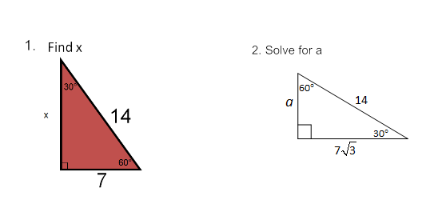

3. 4. 5.

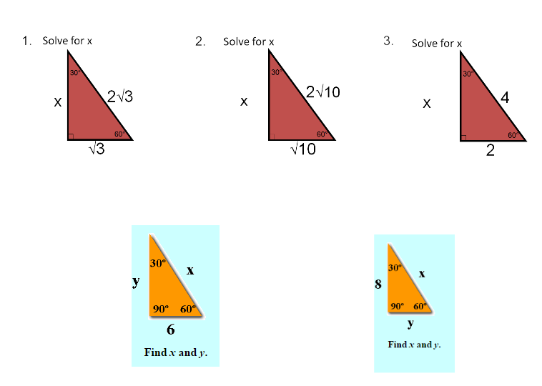

Station #4: Word Problems

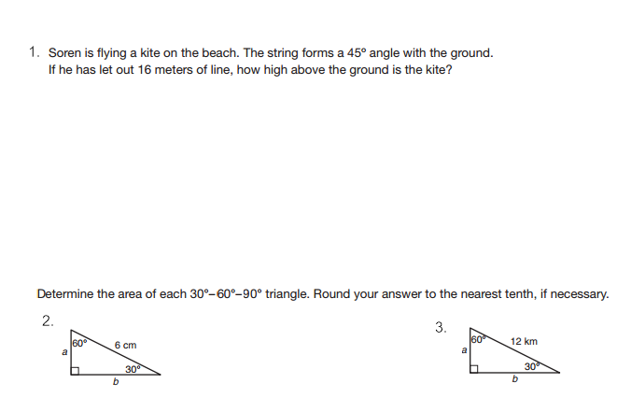

2.



3. A man who is 5 feet 9 inches tall casts a shadow of 8 feet 6 inches. Assuming the man is standing perpendicular to the ground, what is the distance from the top of his head to the end of the shadow?

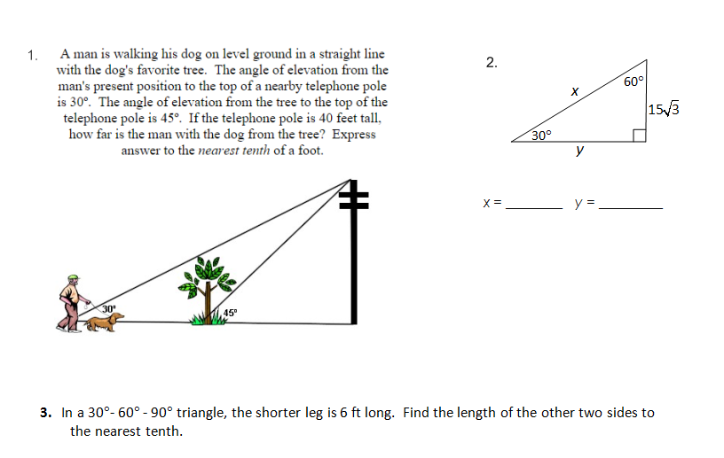**Extra Credit Challenge to earn your group +5 points**